- Nearly Century-old Landmark Church Demolished to Make Way for a More Community-oriented Facility

University Gathering United Methodist Church | Seattle, WA (formerly University Temple UMC)
https://ugathering.org/

The congregation of this nearly century-old church made the decision to replace its building and change its name to be more relevant to current and future community needs. It took years of discussion and several studies to get to this point. The building was demolished in 2021, and plans are underway for a new structure.

The church is precious to Reverend Paul Ortiz's congregation, he says, "and yet, the congregation realized that they were spending too much effort and time trying to upkeep an old building that wasn't really suited for life today. They wanted to invest more in people. And so, the difficult decision was made to demolish and reimagine our space."

'Reimagine,' he says with intention, because the church is not gone for good.

Rather than continue investing money into, say, the finicky furnace, Ortiz says the congregation wanted to create a space that reflects the community's needs today.

… when it's complete, the new space will include student housing run by a community group; an all-ages performance space, which University of Washington students advocated for; a cafe, also run by a community group that has not yet been selected; and, most importantly, an airy wilderness-themed gathering space, the pews which will not be stuck to the ground but easily moveable to change the space as they desire.

Leaders of the congregation say it’s the best way to remain sustainable and remain in the neighborhood.
https://www.kuow.org/stories/i-was-baptized-here-i-thought-i-d-have-my-memorial-there-university-district-bids-adieu-to-historic-church

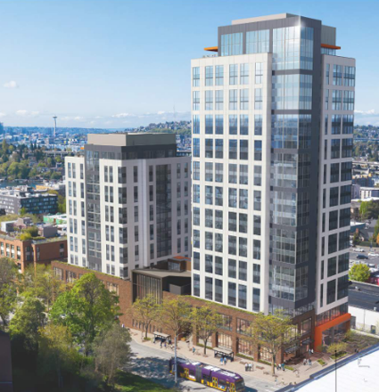
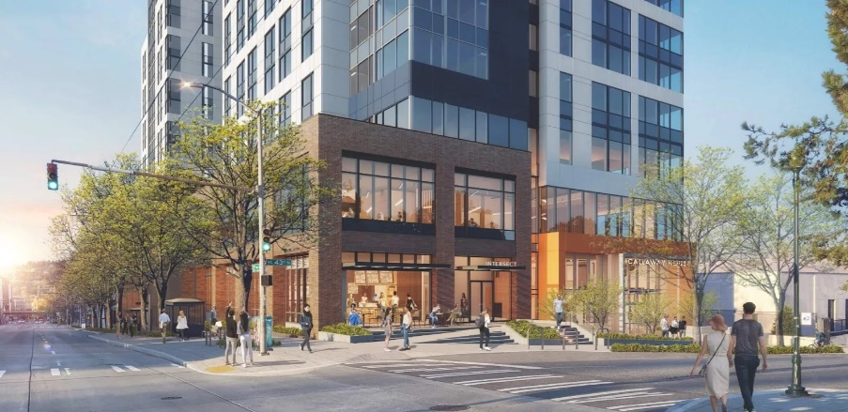
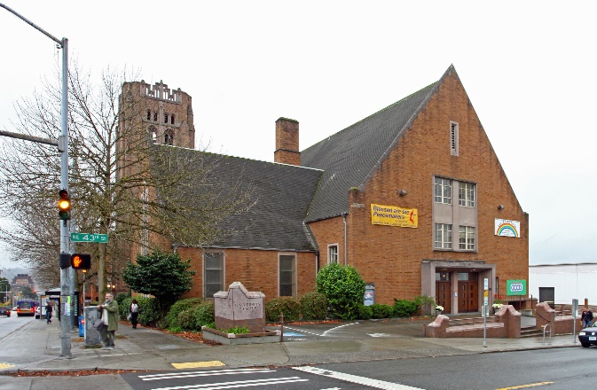
Old church building Vision of a new future (same corner) Full development view

University Temple’s mission is to not only serve its congregation, but also the surrounding community, and they felt led to expand their ministry to new facilities. These facilities include a larger sanctuary to promote congregational growth, an engaging intersect at 43rd and 15th to encourage community interaction, a welcoming church entry at 15th with overhead coverage to promote interaction even in inclement weather, and a church mission space that can be used flexibly for childcare, community meals, events and more.

The project will be a partnership between the church and a developer of student housing. The plans call for two residential towers atop a “pedestal” of church operational facilities, including a sanctuary, nursery school, shelter, community-run café and other services.

The affiliated Wesley Foundation has a history of its own worth reading, especially as it relates to that organization’s facilities:
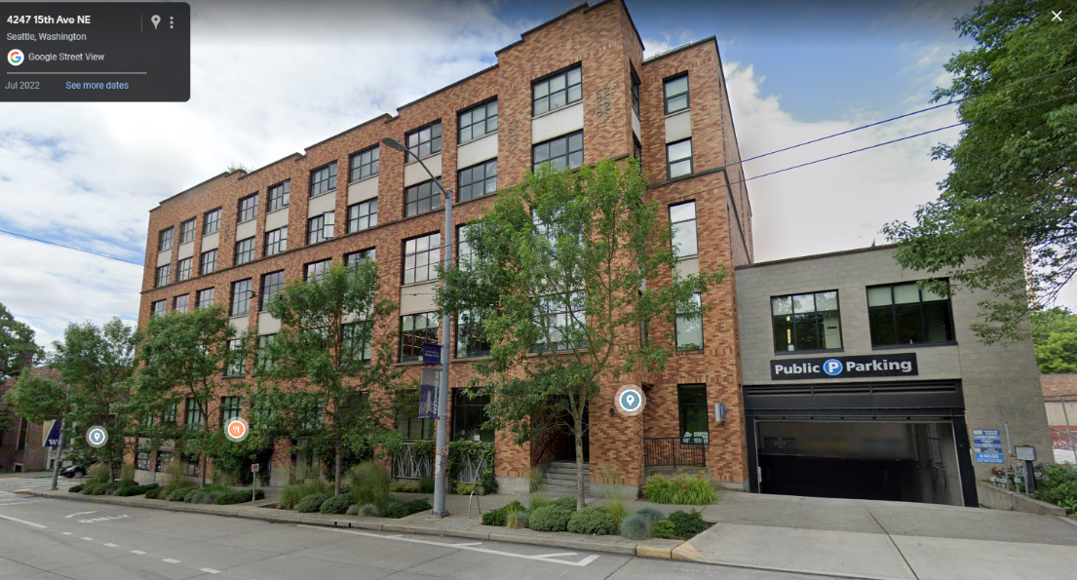
https://ugathering.org/wp-content/uploads/2017/07/UTUMC_History.pdf
(pdf page 105)
More info here

Wesley Foundation & developer partnered to build a multi-use building with public paid parking that provides income for the Foundation.

- Celebrating 100 Years in Chicago Highrise Tower

Chicago Temple United Methodist Church | Chicago, IL
http://www.chicagotemple.org/about/

More info here
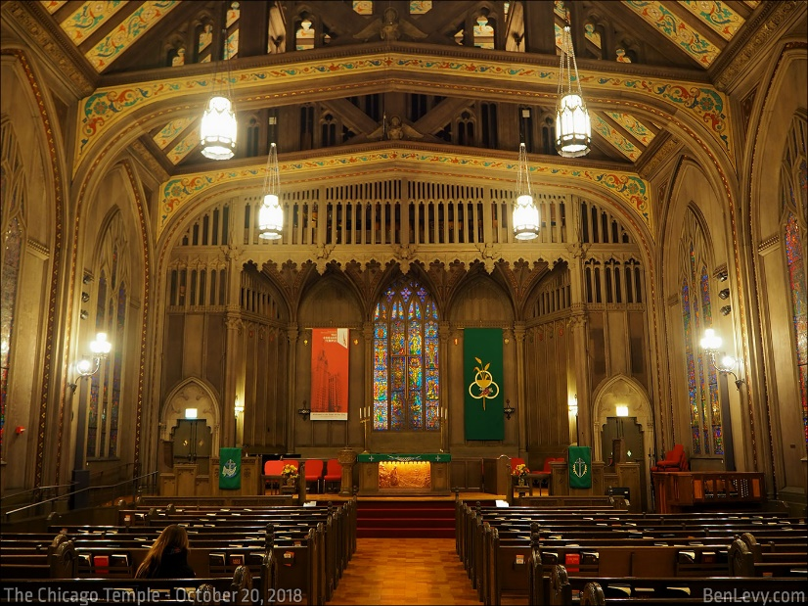
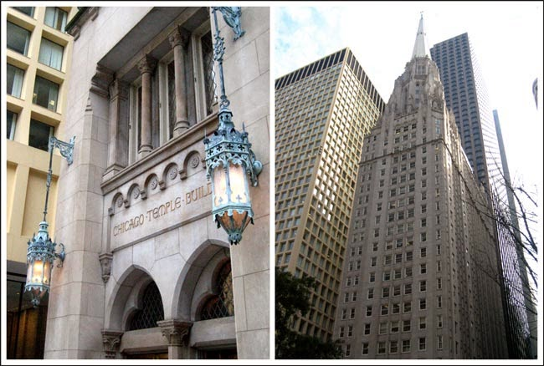
- The family who donated the plot to the church in the 1830s stipulated that the property would remain in the Methodists hands as long as they remained on the deeded corner.
- From a log cabin, the building on the site eventually became a 4-story dual use building, with commercial and office space on the first 2 floors and a 2-story auditorium/worship space above.
- The current building, dedicated in 1924, is nearly 400 feet tall, including its 140-foot spire.
- The congregation stills gathers for worship in the first-floor sanctuary that seats about 500 people.
- Located on the second floor are the Dixon Chapel, James Parlor, the Heritage Room and church offices. The third and fourth floors house the classrooms and nursery, a conference room and a choir room. Floors five through 21 are rented as offices, mainly to lawyers who prize the proximity to the city, county and state buildings.
https://chicagodesignslinger.blogspot.com/2015/02/chicago-temple-building-chicago.html

- Downtown Church Trades Tradition for New Facility Focused on Community Needs

Central United Methodist Church | Arlington, Virginia

DCS Design has officially broken ground on Ballston Station, a multi-use redevelopment of Central United Methodist Church (Ballston) located at 4201 Fairfax Drive in Arlington. In partnership with Arlington Partnership for Affordable Housing (APAH), the project will replace the existing church with an eight-story building that includes 144 committed affordable homes, CUMC’s new sanctuary space, and community amenities including a commercial kitchen for onsite food distribution, a meeting hall, and an early childhood education space to accommodate approximately 90 children. Project completion is expected for Spring 2024.

The historical cemetery located on the church site will remain and be integrated into the new design.
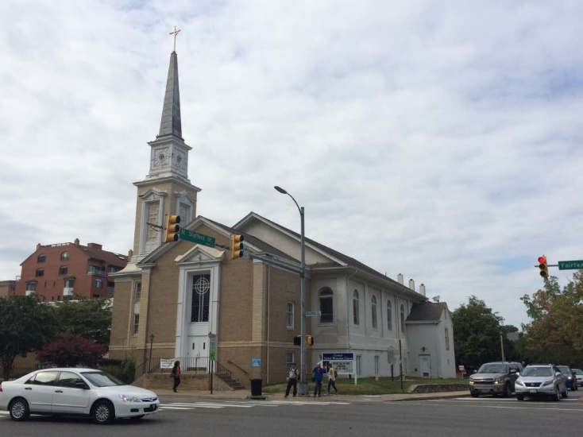
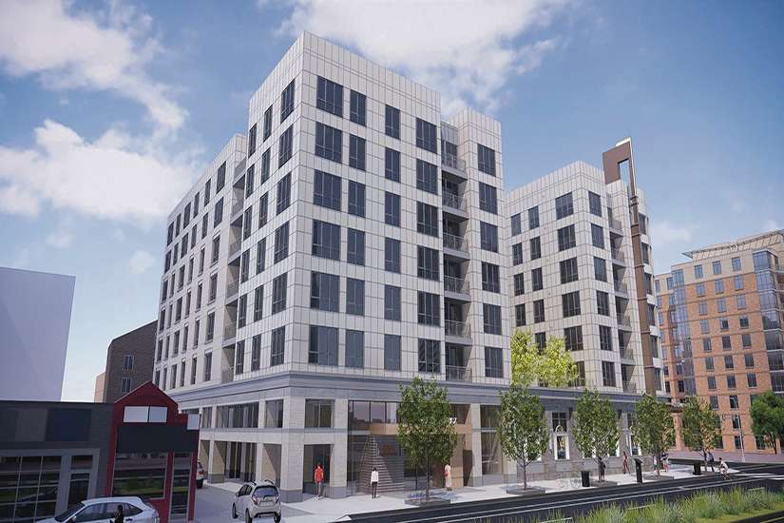

- A New Vision for an Old Church in Midtown Manhattan

St. Peter’s Lutheran Church | Manhattan, NY
https://www.saintpeters.org/the-space
http://www.nyc-architecture.com/UES/UES103.htm
- Church agreed to sell midtown NYC property to Citicorp to build a new 59-story tower
- Citicorp agreed to build a new church on the site, which was accomplished by constructing a sub-terranean sanctuary with street-level entrance under the new high-rise tower
- From neo-Gothic old building to very modern new worship and event space
- Modular design, lots of natural light from windows protruding above the street in rising columns and shards of granite
- The church hosts many concerts, particularly jazz musicians, as well as theater productions and conferences
- In 2019, the church merged with a Spanish-speaking congregation, and both English and Spanish services are available

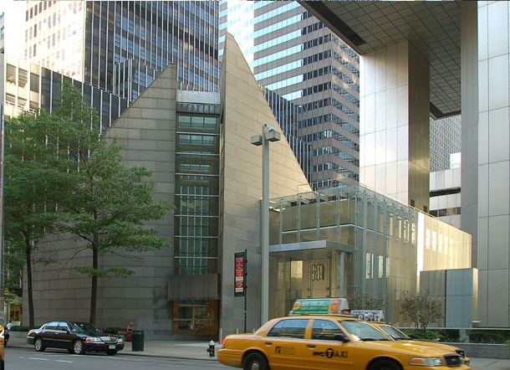
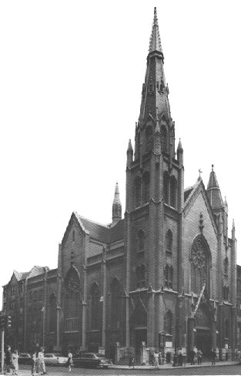
1905 Church building 1977 Church building (sanctuary is recessed below grade with lots of natural light)
More info here

“Our parish life thrives with members of Saint Peter's from all walks of life. We are people of different races, nationalities, sexual orientations, and gender identities. Some of us are first generation immigrants, while others are longtime New Yorkers. Together, we are creatively shaping life in the city.

English and Spanish are our primary languages, both of the congregation, and reflected in our liturgies. Since 2019, we are a bilingual church. We believe that God is calling us to form a community where our diversity is considered our greatest strength, and we welcome you to join us on this journey.”

- An Atrium of Light: Creating a Community Hub

First United Methodist Church | Dallas, Texas
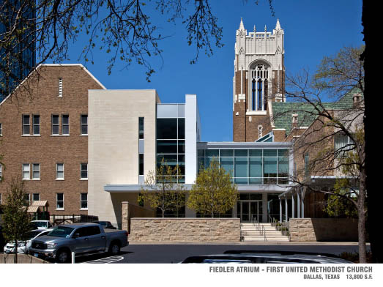
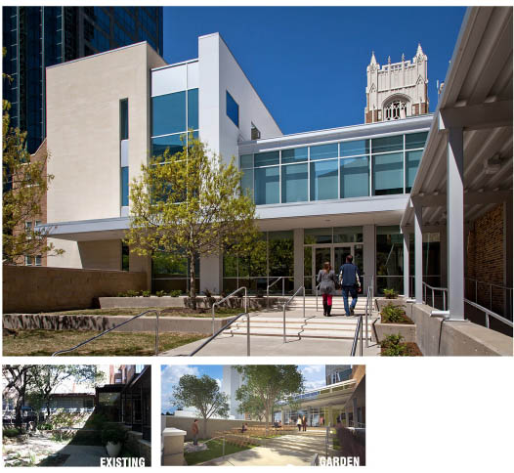

While the new atrium is quite modern,
the church preserved its traditional sanctuary.
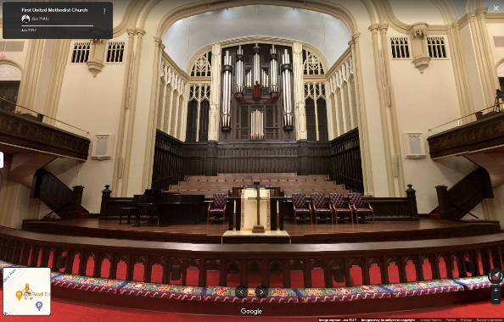

More info here
“…As an entrance, the new façade presents an openness and transparency in alignment with the contemporary ministries of the 21st-century urban church. Eliminating barriers and constricted corridors is a meaningful reflection of the church’s values and mission in the world…Perhaps most important, this project put us on a path to dream even bigger about how our physical church building can be leveraged to serve an urban mission field in profound new ways. Around noon each Sunday morning, an inspired congregation departs FUMC Dallas through what was once a cluster of dark offices and narrow corridors, and is now a renewed, light-filled heart for the campus that propels them toward a world in desperate need of its grace and love.”
https://sacredplaces.org/church-atrium-renovation/

- Urban Church with Focus on Community Plans New Facilities to Improve Service Delivery

Glide Memorial Church, San Francisco, CA
https://www.glide.org/
Glide Memorial Church actively demonstrates its calling to be “a sanctuary for all people” through active worship and an immense amount of community support. GLIDE is a nationally recognized center for social justice, dedicated to fighting systemic injustices, creating pathways out of poverty and crisis, and transforming lives. Through our integrated comprehensive services, advocacy initiatives, and inclusive community, we empower individuals, families and children to achieve stability and thrive.

To ensure critical community services can continue well into the future, Glide is considering building a new facility purpose-built to fulfill its mission. The church sanctuary will remain, while the service center at the rear of the building and the neighboring vacant lot would be redeveloped. The project is in its early stages. https://www.glide.org/real-estate-preliminary-project-assessment-ppa-faq/
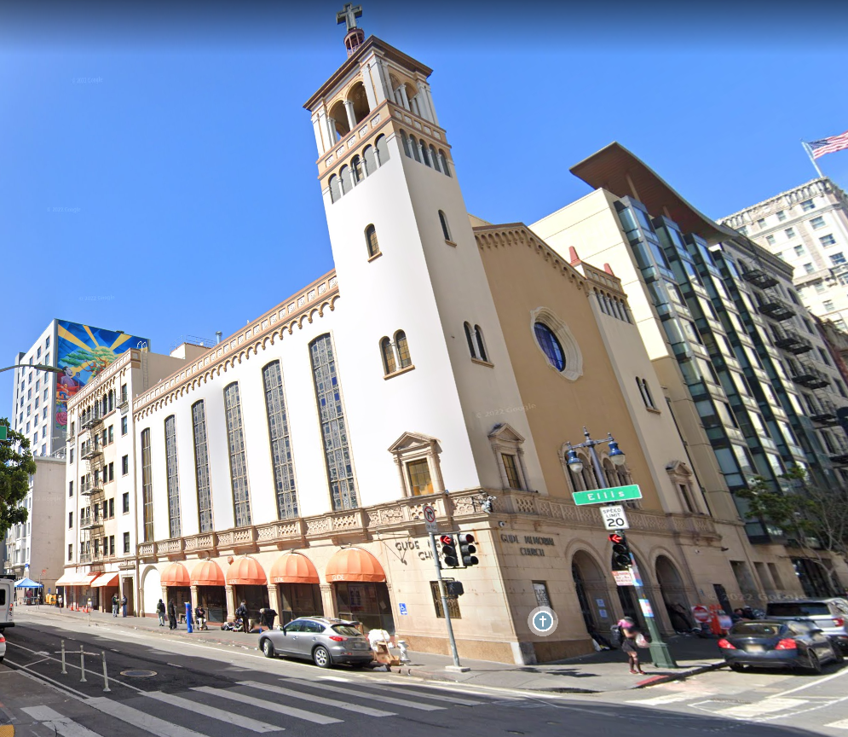
More info here
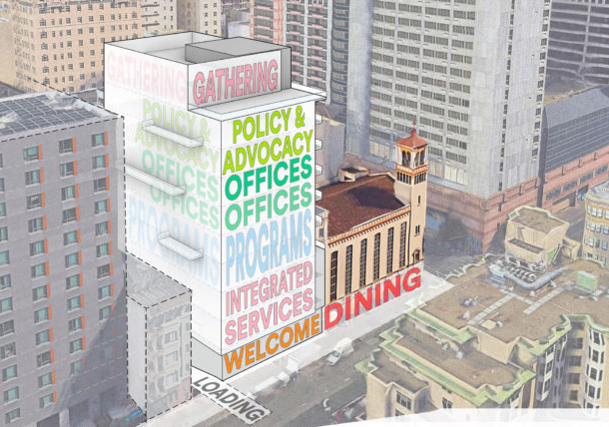

- Church Parking Lot Sold to Developer; Free Parking for Church in New Development

Christ United Methodist Church (St. Petersburg, FL):
https://stpeterising.com/home/2019/2/27/mixed-use-high-rise-to-bring-new-class-a-office-and-a-boutique-hotel-to-downtown-st-pete
https://www.businessobserverfl.com/article/denunzio-group-stpete-development-partnership
- Church to sell its surface parking lot to a developer for $5.3M
- City will contribute $9M to the development and own 4 floors of parking in the development
- Church will have free parking on Sundays in the new structure

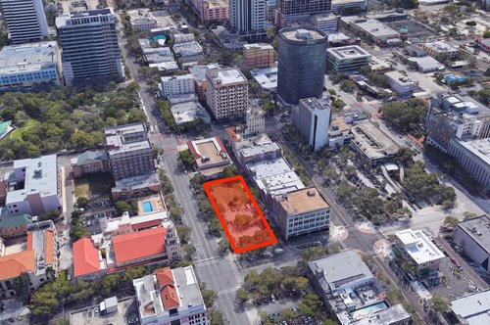
More info here

Church parking lot
Christ United Methodist Church
- Modernizing a Historic Landmark Chapel
More info here
Bigelow Chapel Renovation/Addition | Watertown, MA
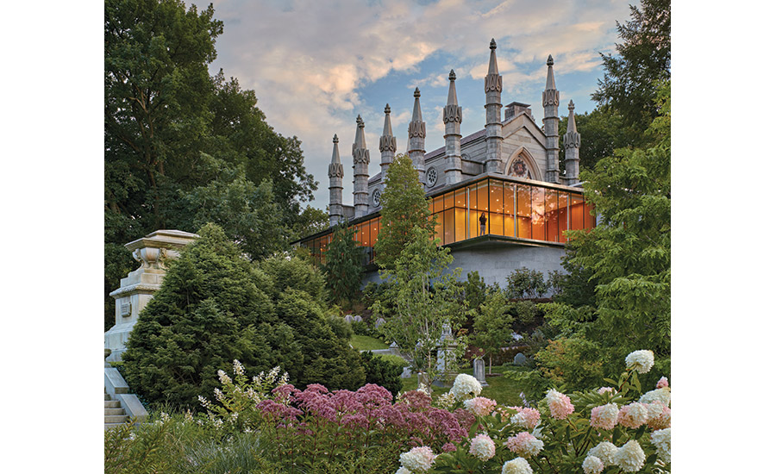
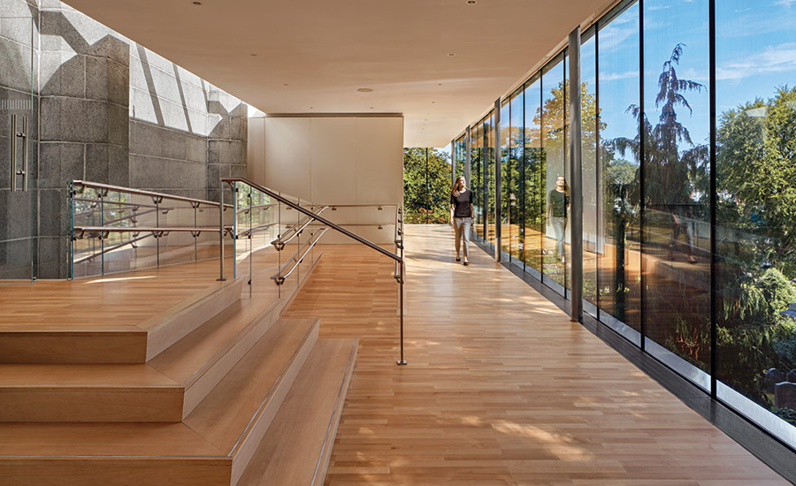

Mount Auburn Cemetery, consecrated in 1831 and designated a National Historic Landmark in 2003, is recognized as one of the most significant designed landscapes in the United States. The transformation of its chapel focused on revitalization and a new crematory. In addition to making the chapel accessible, the restoration seamlessly incorporates fire-protection and improved lighting, lowers the chancel to its original height, and restores the rose window. The glass-walled addition is detailed to maximize transparency and preserve the architectural identity of the chapel. The addition is kept low and horizontal in juxtaposition to the verticality of the chapel’s ornate spires. Following the cremation ceremony, the doors to a gathering room open, and, in an affirmation of life, participants return to the landscape’s panoramic views.
https://sacredplaces.org/watertown-ma-bigelow-chapel/

- Creating a Welcoming Space

St. Peter’s Parish Multipurpose Space | Kansas City, Missouri

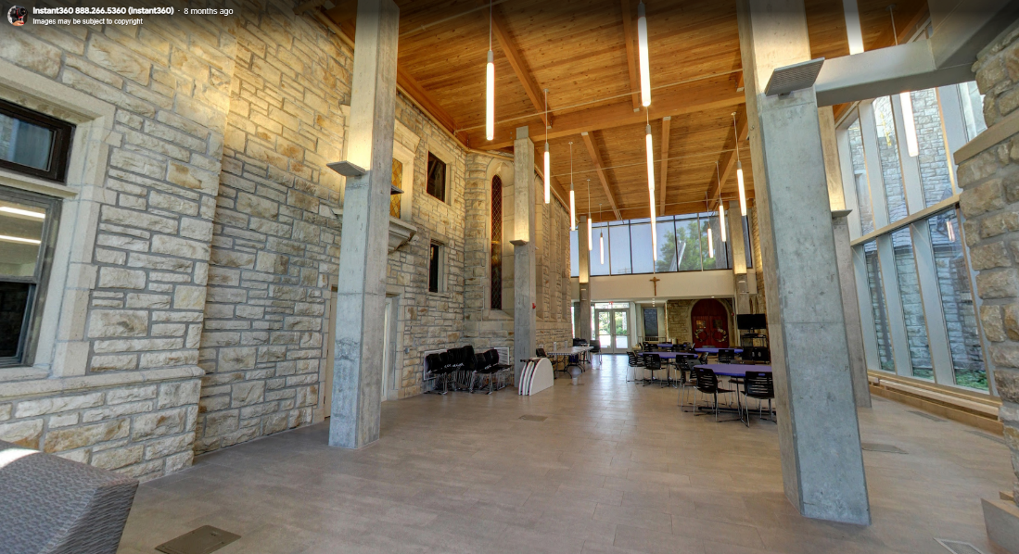
St. Peter’s Parish needed a new multi-function gathering space to host students and parishioners. By reimaging a little-used passage between a school and the church, a new 2,900-square-foot multipurpose space emerged. The new design provides an interior connection between the two structures’ unaligned floor levels and allows daylight to pass through the church’s stained-glass windows.

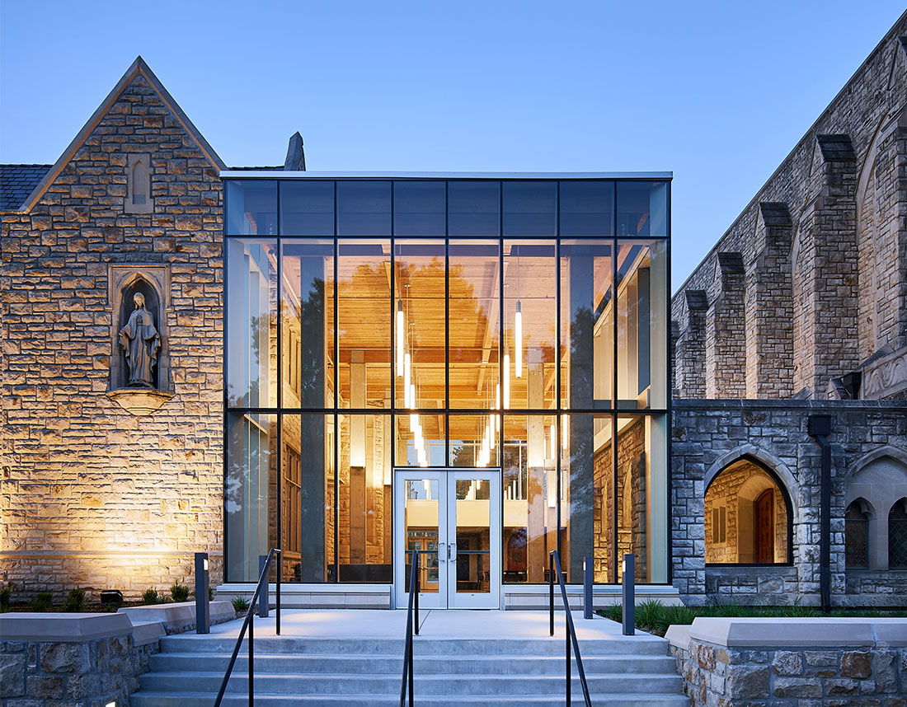
With its straightforward language of structural silicon-glazed curtain wall, unadorned concrete columns, and timber roof structure, the addition is intended to be as transparent as possible. The design also acknowledges the rich, hand-hewn textures of the existing native-stone structures. Lightness and verticality are emphasized with tall, slender columns, curtainwall framing, and long vertical pendant fixtures in contrast to the surrounding buildings’ weight and horizontal stone coursing. St. Peter’s Parish’s interior character is defined more by the existing limestone and the surrounding neighborhood’s tree cover.
https://sacredplaces.org/kansas-city-mo-st-peters-parish/

More info here

- God-size Ambitions Result in Affordable Housing in Atlanta through a Sustainable Partnership

Atlanta First United Methodist Church | Atlanta, GA

A historic Atlanta church’s “God-size” ambitions to create hundreds of affordable housing options broke ground Oct. 2022.

The development will create inclusive housing on 1.8 acres next the gothic-style sanctuary from 1903…[T]he land in question is currently home to pay parking lots, an unused outbuilding, and an education building.

…[P]roject benefits would include activating church parking lots that are underutilized most days, while "providing new mixed-income residences with deep levels of affordability.”

Atlanta First UMC isn’t expected to spend anything to develop the site, and all marketing costs should be refunded through future profits, officials have noted. No land will be sold—the church will instead lease the ground to developers—and the deal is expected to provide the church “multiple streams of income… for years to come.”

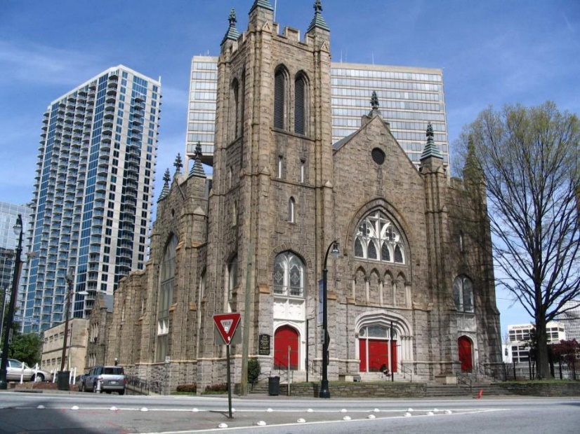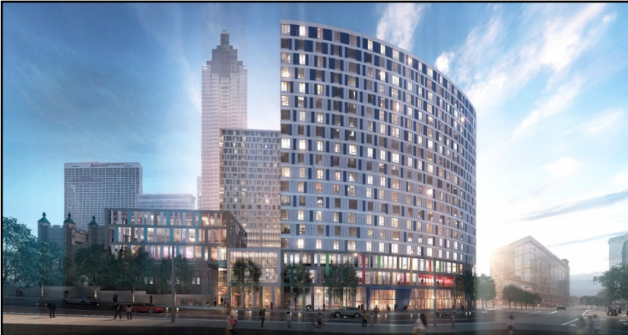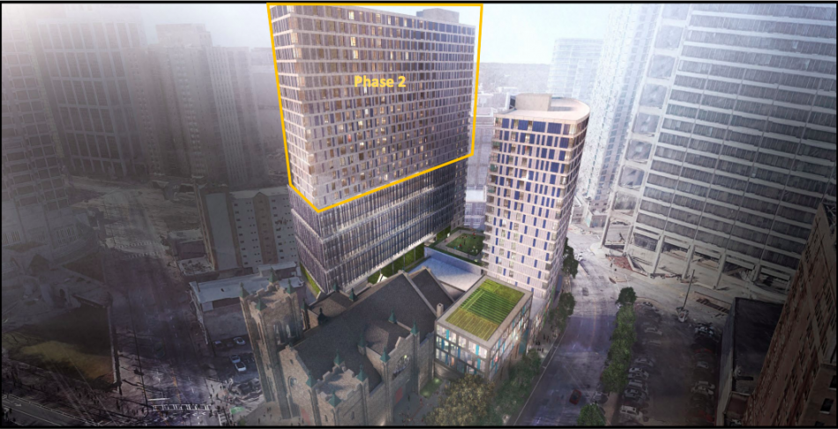
More info here
https://atlanta.urbanize.city/post/affordable-housing-downtown-church-property-groundbreaking-scheduled

- Second Century Project: Building for Our Next 100 Years

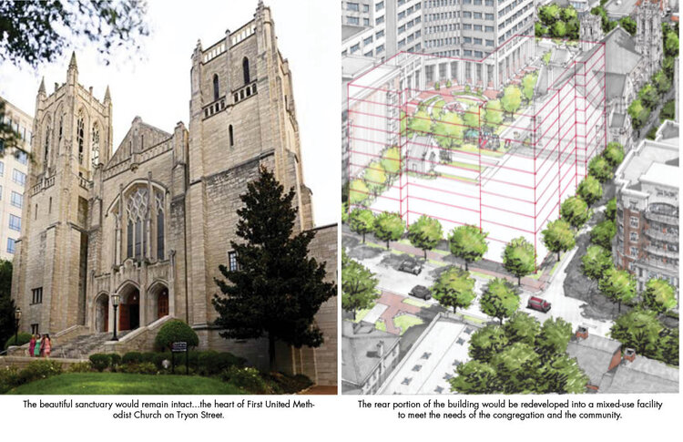
First United Methodist Church | Charlotte, NC

The church is taking a strategic look at how it might align its facilities with its ministries to better serve the congregation and the community. While the beautiful sanctuary houses worship services, concerts, and plays, the support area behind the sanctuary – the offices, gym, meeting halls, and classrooms – are used less regularly. Nearing the end of their first century, these facilities are particularly expensive to maintain and less frequently used. Second Century Project is a team of volunteers and clergy who are exploring the possibilities for maintaining the sanctuary and careful redevelopment of the back half of the remaining complex.
- Service and Partnerships so Neighbors Have a Better Life

Metropolitan United Methodist Church | Montgomery, AL
Beacon Center church ministry

Opened in 2022, the Beacon Center, a ministry of Metropolitan United Methodist Church, offers 31 community services, ranging from a food pantry to screening for HIV to counseling and education support. The services the Beacon Center provides aren’t confined to the building. They will offer free Wi-Fi to the community that can be accessed from the parking lot.

Pastor Richard Williams frames the Beacon Center this way: “We exist to remove barriers from our neighbors, so they can have a better life." As a pastor, Williams firmly believes, “If I’m going to be there for the birth and the funeral, then I should care about the in-between as well.”

Andrea Callahan, the field director for the Beacon, adds, “The most important thing about the Beacon Center, it's a safe haven that helps people deal with trauma."

The goal from the start was to, "come up with sustainable plans to assist our neighbor." The Beacon Center relies heavily on its volunteers. The Center also serves as a place where people who are mandated by the courts to volunteer can go. There are about 30 people who use that program.

“We have a lot of friends. All of the work that we do is because of partnerships,” Williams said.

Williams partnered with Trenholm Community College to launch a GED program at the church. He partnered with Alabama State University to launch a paid internship that will provide housing to students in exchange for their service at the church. He partnered with Davis Elementary to launch a food pantry at the school, where 86% of students are considered economically disadvantaged.
More info here
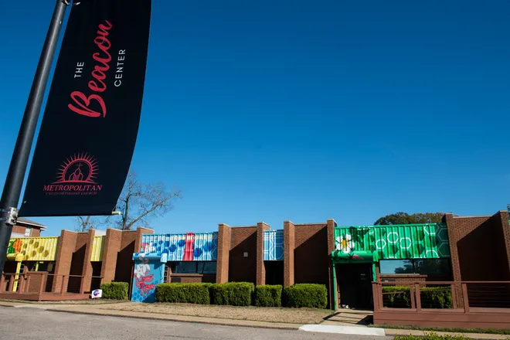
https://www.montgomeryadvertiser.com/story/news/local/2022/11/30/beacon-center-montgomery-al-offers-bright-future-for-residents/69588036007/

Additional Interesting Articles About Today’s Church Needs

Designing Worship Spaces with Millennials in Mind

5 do's and 5 don'ts for using your church building well

The Flexible Church Building

4 Ways to Reimagine Large Gathering Spaces for Smaller Groups
- A Welcoming and Inclusive Addition Supports Mission Outreach

Central United Methodist Church | Traverse City, MI
More info here
https://www.tccentralumc.org/about/

CUMC is a friendly, inclusive and thriving downtown church that has been serving the Traverse City area for over 150 years. The present building with its classical dome was dedicated in 1913.

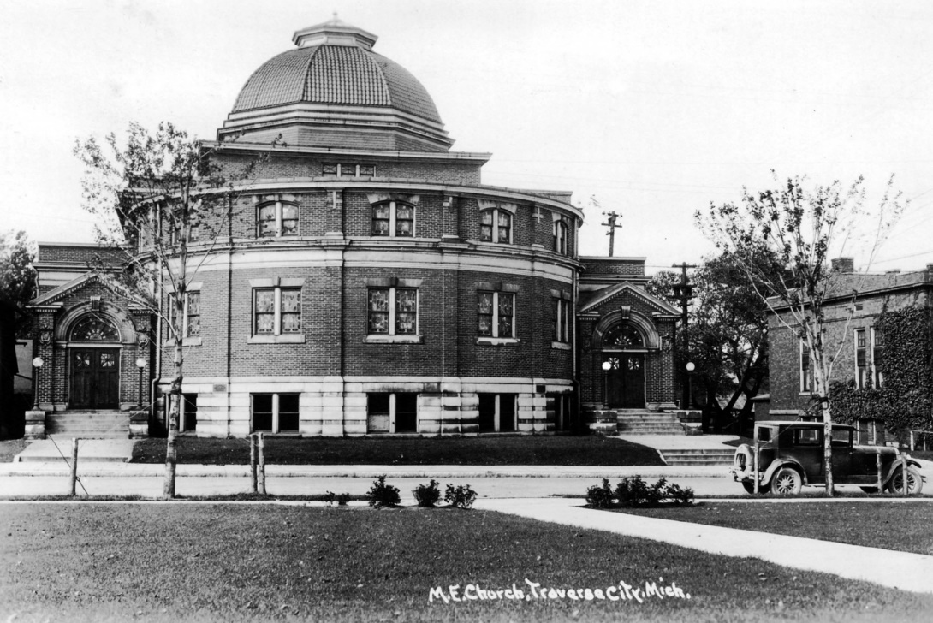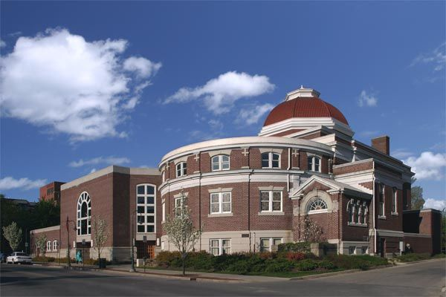

Major expansions were made in the 1990s to add classrooms, offices, a chapel and a lounge. A new narthex and accessible entry doors extend to the front sidewalk. The narthex is now an inviting entry space with easy access via a large elevator to all 4 levels. Four wheelchairs are available for guests, one on each floor, and wheelchair-accessible seating is provided in the sanctuary. Accessible restrooms are available on each floor.

The well-planned additions of the 1990s meet the present needs of the church and blend well with the original building architecture.

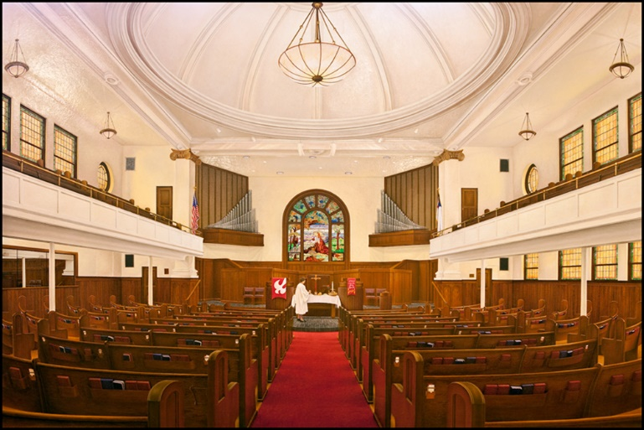
The sanctuary has balconies on 3 sides and a stunning large stained-glass window. The space has the sacred feel of a 19th century church. Large video screens have been added on both sides of the front chancel area to display words during hymns.

A major focus of CUMC is its Mission Outreach program, especially to the local Traverse City community. Free breakfast is served 5-6 days a week for low income and for homeless community members. Participants can use the church as their mailing address and showers, haircuts, bus passes, housing and employment contacts are available. A worship service once a year remembers individually the homeless people who have died during the past year with their names, ages and photos if available, for a last moment of dignity. The church also provides volunteers to staff the local homeless shelter for two weeks in the winter. Over 20 other outreach activities and organizations are supported by the congregation.
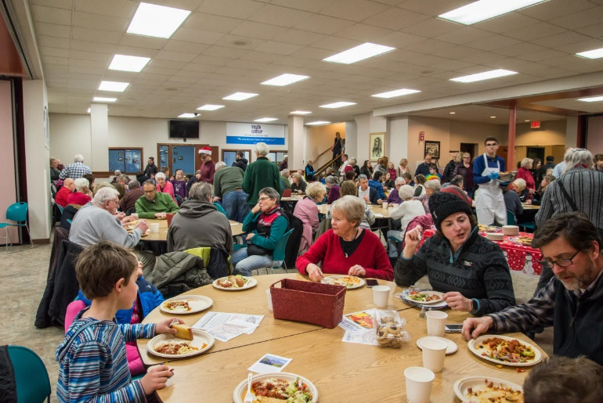
Wednesday Serve dinner is sponsored by rotating church groups and provided weekly in the social hall during the school year. The dinners are well attended by many church members as well as by people in search of a free meal. These weekly dinners are a great way to connect with other church members and the community.

The front of the church building is open during the busy Cherry Festival so the public can use the restrooms.

What is most important to remember is that the question “What shall we do with our building?” is a mission question. It often feels like a money question, but as a church, the first question is about God’s mission in our town, at this time. What is God calling us to do as the body of Christ, and what role does our building play in that?
https://www.sneucc.org/blogdetail/what-s-in-a-building-15412115

